SIT 218/738: Secure coding

**Credit task 2.2C: Security configurations of Tomcat server**

**Overview**

In the first task we changed the server banner to send a custom information about our tomcat server not revealing the version or the web server type. However, you might have noticed the response still consists details of the web server due to the default index page.

**Task1:** The default Tomcat manager page should not be accessible from the root path (/ -- eg. Localhost:8080) instead you should get a HTTP status 404 page when accessing <http://localhost:8080>. The admin page should however be accessible from <http://localhost:8080/manage-tomcat.jsp> **Hint: ROOT folder/index.jsp**

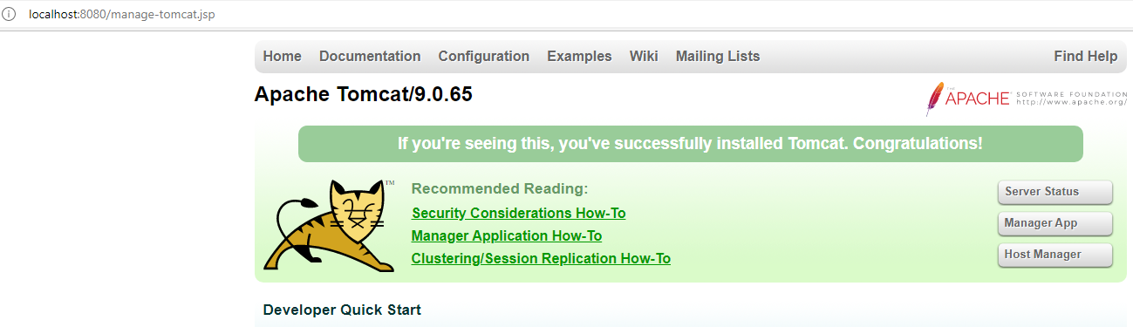

**Task2:** Scanning using namp still shows tomcat as the server and the version number. Make the necessary changes to prevent nmap from picking the information about server. **Hint: web.xml**

Before changes

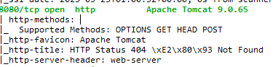

After changes

Use the below HTML code to create a new error page.

<html>

<head>

<title>Page not found</title>

<link rel="icon" type="image/x-icon" href="favicon.ico">

</head>

<body>

<h1>

<center>The Page You looking for is not available, please connect with administrator.</center>

</h1>

</body>

</html>

Please do your own research and try to collect as much information as possible. When you use information from other sources, remember to cite them, else it will be considered as plagiarism. You CAN NOT do direct copy paste even if you provide proper in-text citations and bibliographic references at the end.

**Submission Requirements:**

Submit one PDF file with your explanation of security principles and a real-world example of its violation via OnTrack. The submission should include:

1. Screenshot of changes made for task 1 and the desired result
2. Screenshot of changes made for task 2 and the desired result as per the task requirements with the custom error page shown to user when HTTP404 error occurs.